DBMS
EXPERIMENT NO 02

Conversion of ER diagram to Relational model : Travel Agency

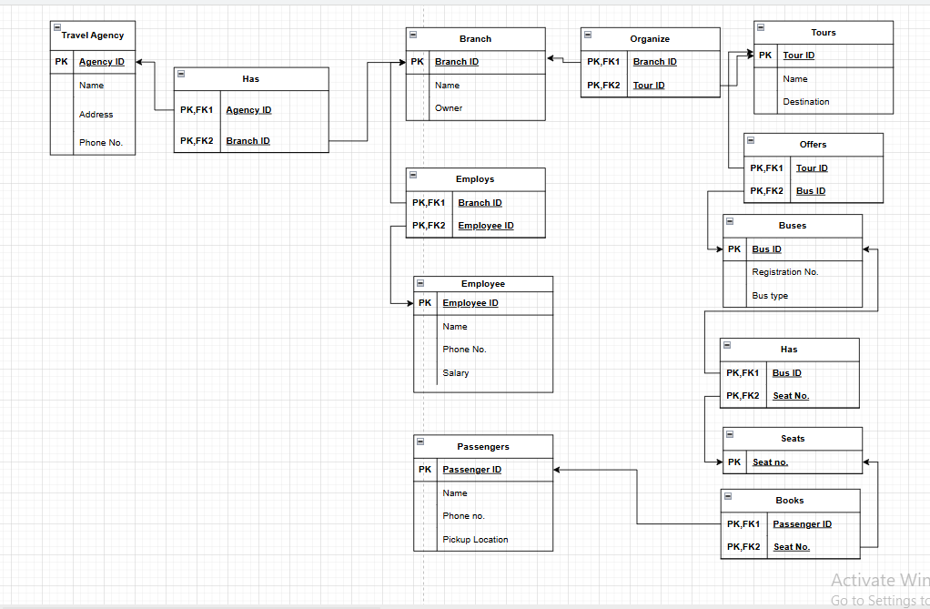

AIM

To convert an Entity-Relationship (ER) diagram of a Travel Agency system into a Relational Model.

THEORY
An Entity-Relationship (ER) diagram is a conceptual representation of a database that shows entities, attributes, and relationships among them. It is used during the design phase of a database to understand the structure and data flow of the system.
A Relational Model represents data in the form of tables (relations), where each table consists of rows (tuples) and columns (attributes). Converting an ER diagram into a relational model is an important step in database design, as it transforms a conceptual model into a logical schema suitable for implementation.
The conversion process involves the following steps:
- Each entity in the ER diagram is converted into a table.
- Attributes of the entity become columns of the table.
- A primary key is selected to uniquely identify each record.
- Relationships between entities are represented using foreign keys.
- One-to-many relationships are implemented by adding a foreign key in the “many” side table.
- Many-to-many relationships are converted into a separate table containing foreign keys of both entities.
- Weak entities include the primary key of the parent entity as part of their key.
This process ensures that the database structure is organized, avoids redundancy, and maintains data integrity.

CONCLUSION
Thus, the ER diagram of the Travel Agency system was successfully converted into a relational model. The entities, attributes, and relationships were properly mapped into tables with appropriate primary and foreign keys. This conversion helps in designing a structured and efficient database for implementation.

STEP-BY-STEP: Draw Relational Model in Draw.io

1. Open Draw.io
- Go to: https://app.diagrams.net
- Select Device → Click Create New Diagram
- Choose Blank Diagram

2. Enable Proper Shapes (Important)
- Left panel → Click More Shapes
- Enable:
  - ✔ Entity Relation
  - ✔ General
- Click Apply

3. Create Tables (Entities)
Drag Rectangle (or ER Table shape) for each table.

Create these tables:

Agency
Agency
-------------------
Agency_ID (PK)
Name
Address
Phone_No

Branch
Branch
-------------------
Branch_ID (PK)
Name
Owner
Agency_ID (FK)

Employee
Employee
-------------------
Employee_ID (PK)
Name
Phone_No
Salary
Branch_ID (FK)

Tour
Tour
-------------------
Tour_ID (PK)
Name
Destination

Organizes
Organizes
-------------------
Branch_ID (PK, FK)
Tour_ID (PK, FK)

Bus
Bus
-------------------
Bus_ID (PK)
Registration_No
Bus_Type

Offers
Offers
-------------------
Tour_ID (PK, FK)
Bus_ID (PK, FK)

Seat
Seat
-------------------
Seat_No (PK)
Bus_ID (FK)

Passenger
Passenger
-------------------
Passenger_ID (PK)
Name
Phone_No
Pickup_Location

Booking
Booking
-------------------
Passenger_ID (PK, FK)
Seat_No (PK, FK)

4. Arrange Layout (VERY IMPORTANT)
Place tables like this:
Agency
↓
Branch
↓
Employee

Branch —— Organizes —— Tour —— Offers —— Bus —— Seat
↓
Booking
↓
Passenger

5. Connect Tables (Relationships)
Use Connector (arrow line) from toolbar:
- Agency → Branch
- Branch → Employee
- Branch → Organizes
- Organizes → Tour
- Tour → Offers
- Offers → Bus
- Bus → Seat
- Seat → Booking
- Passenger → Booking

6. Add Relationship Labels (Optional but Good)
- Double click on lines → write:
  - 1 : M
  - M : N

7. Formatting (For Better Marks)
- Make Primary Keys bold
- Align boxes properly (use Arrange → Align)
- Keep spacing equal
- Avoid crossing lines

8. Export Diagram
- File → Export As → PDF / PNG
- Use PNG for submission screenshots

